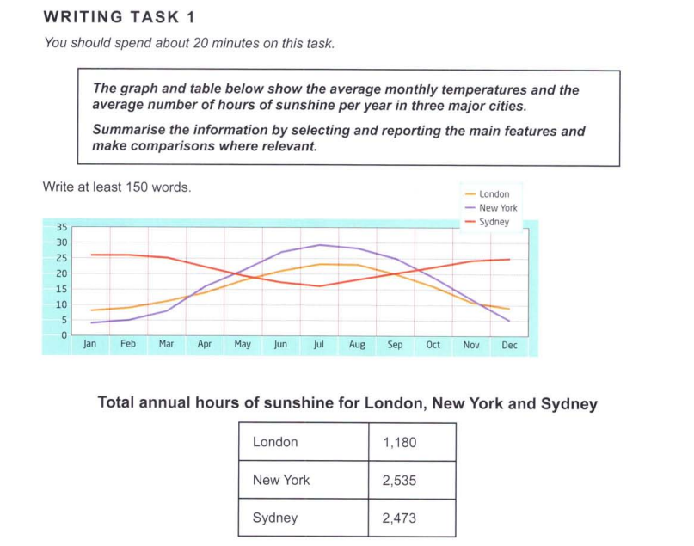

From the graph, we can see the average monthly temperatures of three cities over the span of a year. The table gives us information about the average duration for which these cities get sunshine, in hours, in a year.

London and New York reach their peak temperatures in July/August, and the figures drop until December after which they start rising in the new year. New York has more overall variability in its temperatures, with a measured range of 25 degrees Celsius. In stark contrast, London and Sydney have ranges of 15 and 10 degrees Celsius respectively.

A clearly observable pattern is the way in which the monthly averages for Sydney are ‘alternating’ with respect to the other cities. This could perhaps be attributed to the fact that Sydney is in the Southern Hemisphere, and hence experiences hotter conditions in its summer months, around December.

New York and Sydney both get significantly more sunshine in a year than London does, with Sydney’s 2,473 even exceeding double that of London’s 1,180. Meanwhile, Sydney and New York have a relatively small gap of about 60 hours.